Part B:

MS Excel Exercises:

1. Create a worksheet to maintain student information such as Roll No, Name, Class, Marks in three subjects of 10 students. Calculate total marks, average and grade. Find grade for Distinction, First class, Second class, Pass and Fail using normally used conditions.

* Using custom sort, sort the data according to class: - Distinction first, First Class next, and so on. Within each class, average marks should be in descending order.
* Also draw the Column Chart showing the Roll No versus Average scored.

**Before sorting:**

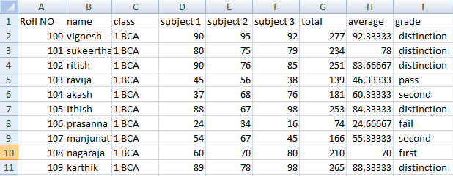

**After sorting:**

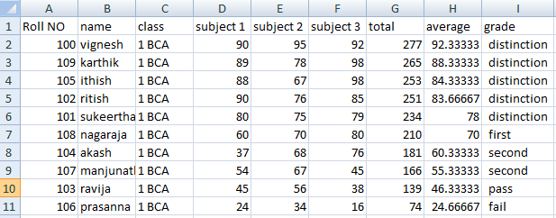

**Column chart:**

1. Prepare a worksheet to store details of Electricity consumed by customers. Details are Customer No, Customer Name, Meter No, Previous meter reading, Current meter reading of 10 customers. Calculate total number of units consumed and total amount to be paid by each consumer using following conditions: If unit consumed is up to 30, charge is 100. 31 to 100 units, 4.70 per unit 101 to 200 units, 6.25 per unit Above 200 units, 7.30 per unit.

* Use Data validation to see that current reading is more than previous reading.
* Arrange the records in the alphabetic order of names.
* Filter the records whose bill amount is more than Rs.1500.

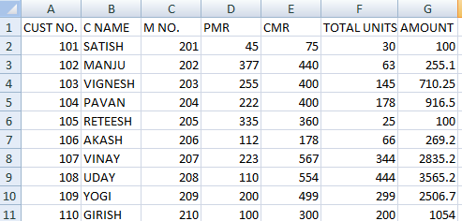

Total unit=E2-D2.

Amount =IF(F6<=30,100,IF(AND(F6>30,F6<=100),(F6-30)*4.7+100,IF(AND(F6>100,F6<=200),(F6-100)*6.25+100+329,(F6-100)*7.3+100+329+625)))

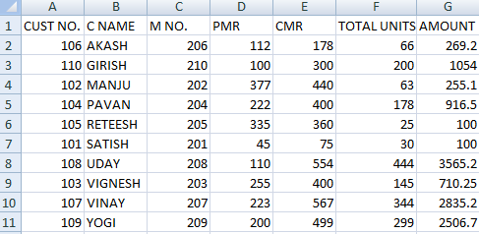

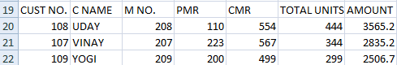

3. Create Employee database having EmpNo, EmpName, DOJ, Department, Ddesignation and Basic Pay of 8 employees. Calculate DA, HRA, Gross Pay, Profession Tax, Net Pay,Provident Fund as per the rule :

DA = 30% of basic pay

HRA = 10% of basic pay if basic pay is less than 25000, 15% of basic pay otherwise.

Gross =DA +HRA+ Basic pay

Provident fund =12% of Basic pay or Rs.2000, whichever is less.

Profession Tax= Rs.100 if Gross pay is less than 10000, Rs.200 otherwise.

NetPay = Gross - (Professional tax + Provident Fund)

* Prepare individual pay slips of (at least 3) employees in another work sheet
* Using Pivot table, display the number of employees in each department and represent it using Pie chart

**EMPLOYEE DATABASE**

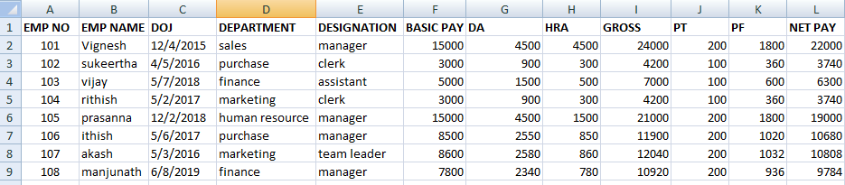

* **Pivot table- displaying the number of employees in each department**  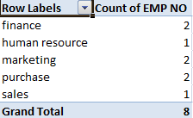
* **Number of employees in each department represented by using Pie chart**

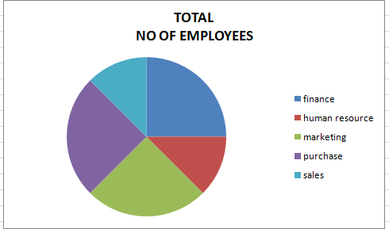

* **Individual pay slips of employees:**

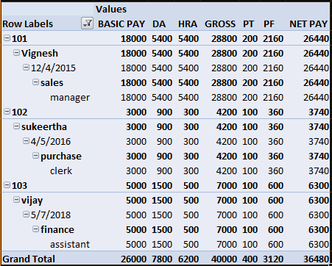

4. Create a table COMMISSION containing the percentage of commission to be given tosalesmen in different zones as follows:

|  |  |
| --- | --- |
| **Zone** | **Percentage** |
| South | 10 |
| North | 12.5 |
| East | 14 |
| West | 13 |

Create another table SALES in the same worksheet to store salesman name, zone name, place, name of the item sold, rate per unit, quantity sold. Calculate total sales amount of each salesman. Referring the COMMISSION table, write the formula to compute the commission to be given.(Hint: Use if function and absolute cell addresses)

Using advanced filtering show the result in other parts of the worksheet.

* Show the records of various zones separately.
* Show the records of only East and West zones.
* Display the details of the items sold more than 50, in South or North zones.

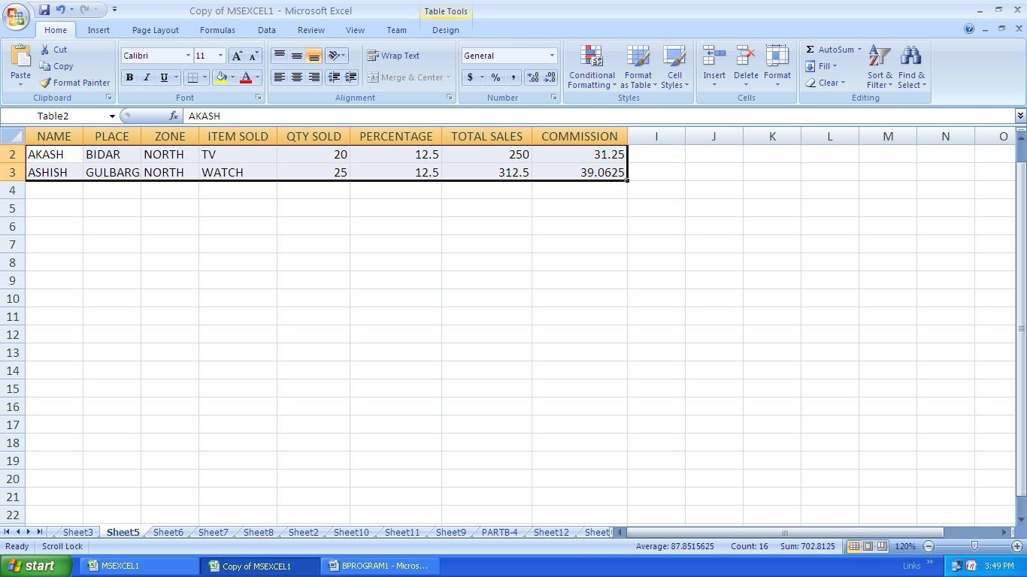**NORTH ZONE:**

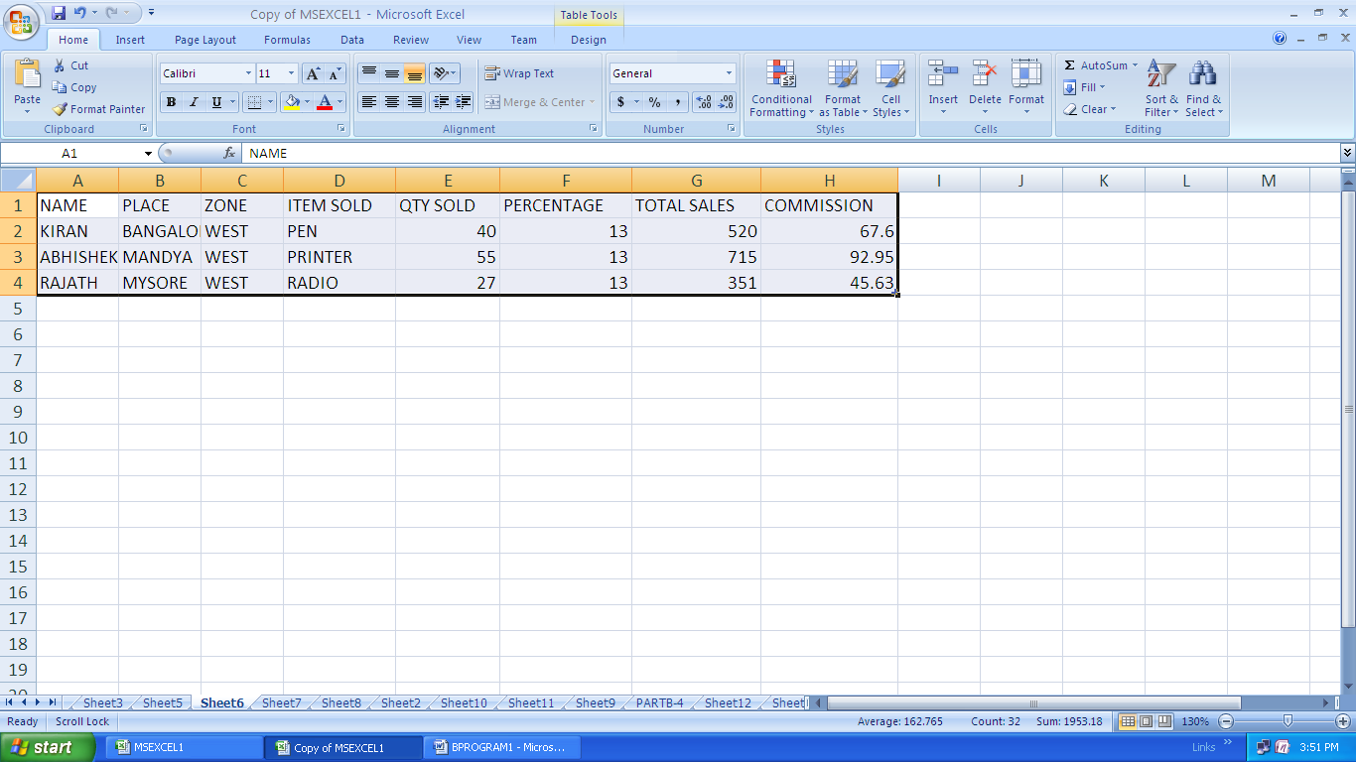**WEST ZONES:**

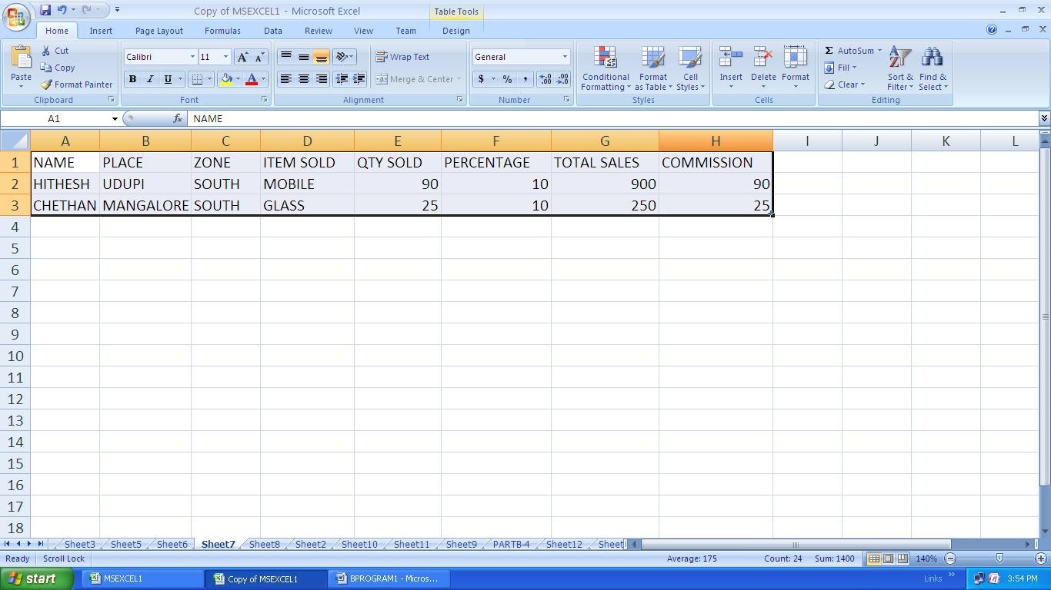**SOUTH ZONES:**

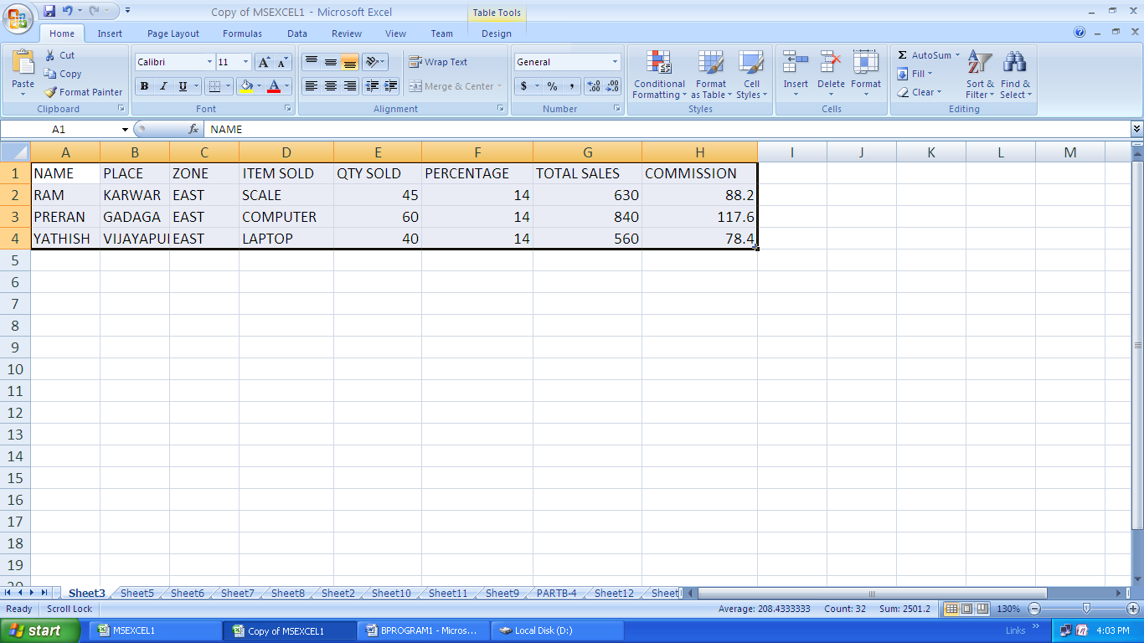**EAST ZONES:**

**EAST AND WEST ZONES:**

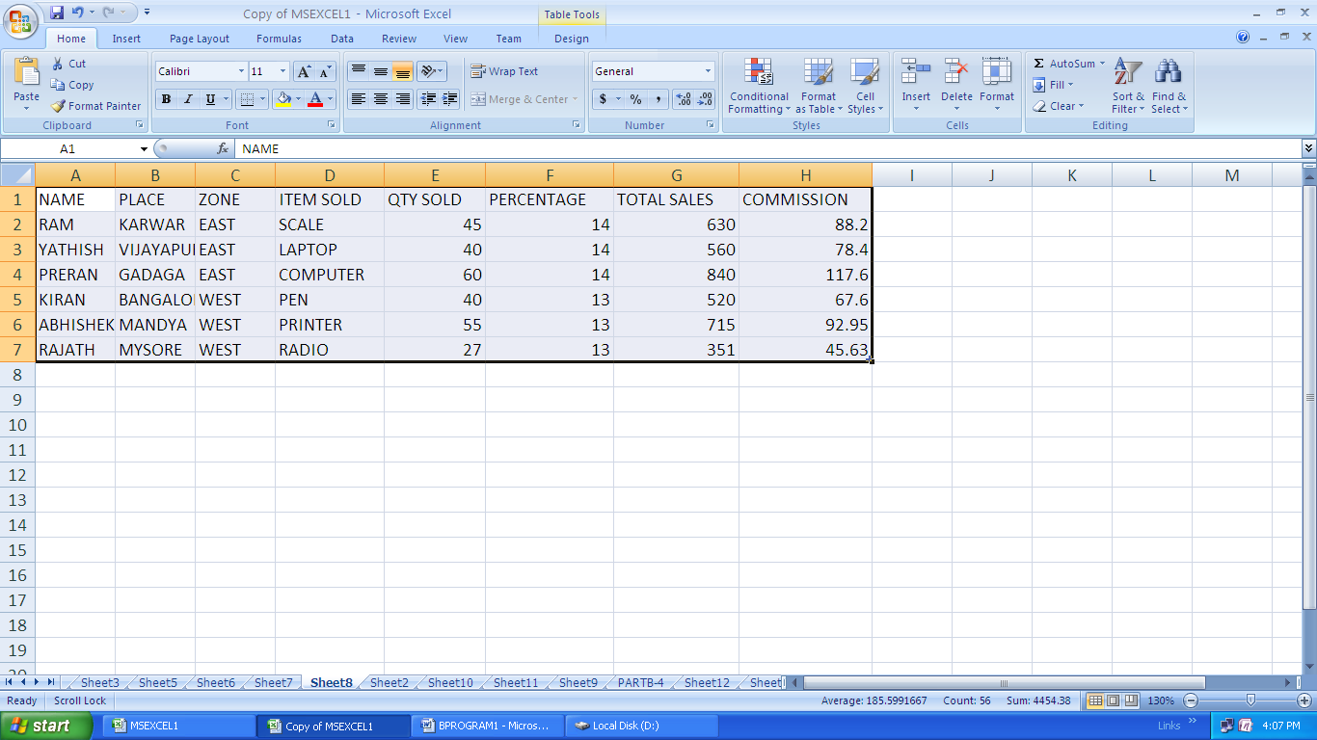

**QUANTITY SOLD MORE THAN 50 IN NORTH OR SOUTH:**

